PROJECT Report

Object Oriented Programming

E-Sports Tournament Management System

Instructor

Abdul Qadeer Mudasar

Submitted by
Samiullah
(2510078)
Abdul Rafay
(2510034)

Department of Cyber Security
Air University, Multan
Table of Contents
- Introduction 1
- Table of Contents 2
- List of Figures 2
- List of Tables 2
- Problem Statement 2
- Objective 3
- UML class Diagram 3
- Class Description 4
- Relationship 5
- OOP Concepts Used 5
- Outputs 6
- Conclusion 9

3. List of Figures
- Figure 7.1: Unified Modeling Language (UML) Class Diagram of the System
- Figure 11.1: Admin Login and Main Sub-Menu Interface
- Figure 11.2: Player Menus

4. List of Tables
- Table 8.1: Detailed Class Description and Member Profiles

5. Problem Statement
Managing e-sports tournaments manually is highly inefficient and prone to administrative errors, particularly when tracking distinct roster compositions, player roles, and volatile team scores. Existing basic software solutions lack secure data compartmentalization, exposing records to unauthorized tampering or misallocations. Furthermore, penalizing integrity issues like cheating or adjusting points dynamically based on infraction severity is difficult without an automated infrastructure. There is a critical requirement for a secure, consolidated console platform that separates Admin and Player access privileges, automates live match fixtures with iterative tie-breakers, enforces administrative penalties, and logs deep historical standings to preserve overall tournament integrity.

6. Objectives
- To design and implement a structured, module-driven C++ application using advanced Object-Oriented Programming (OOP) paradigms.
- To establish robust system security by providing isolated operational workflows via Admin validation and credentialed Team dashboards.
- To ensure data persistence across application restarts using automated file-stream processing (ifstream/ofstream).
- To implement a fair, parameter-driven anti-cheat subsystem capable of scaling point deductions or awarding compensation points.
- To automate tournament lifecycle operations, including a three-tiered match/rematch resolution framework and automated point distributions (2 for a win, 1 for a permanent draw).

7. UML Class Diagram

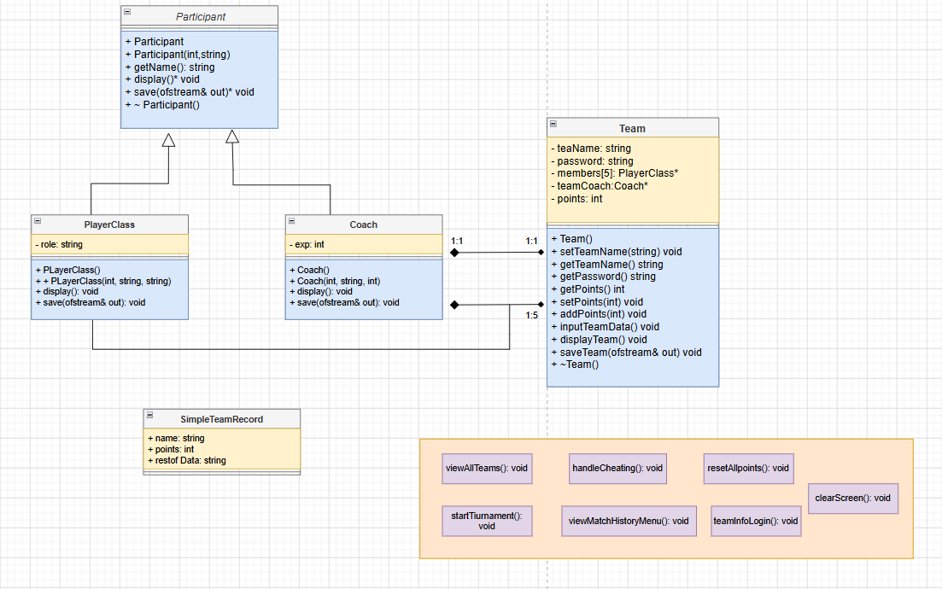

8. Class Description
The system architecture features high cohesion and clear data ownership boundaries. The following matrix profiles the structural units:

Table 8.1: Detailed Class Description and Member Profiles
Class / Struct Name | Attributes (Data Members) | Methods (Member Functions) | Purpose / Responsibility
Participant (Abstract Base) | protected:  int id;  string name; | getName(),  virtual display() = 0,  virtual save() = 0, ~Participant() | Acts as the foundational blueprint for all personnel types and enforces a generic polymorphic interface.
PlayerClass | private:  string role; | display() override, save() override | Inherits from Participant. Explicitly handles tactical role details (e.g., Main vs. Reserve slots).
Coach | private:  int exp; | display() override, save() override | Inherits from Participant. Tracks professional guidance parameters, specifically years of experience.
Team | string teamName, password, PlayerClass* members[5], Coach* teamCoach, int points | inputTeamData(), displayTeam(), saveTeam(), Getters/Setters, ~Team() | Serves as the key domain entity managing credential verification, score metrics, and lineup aggregates.
SimpleTeamRecord (Struct) | string name, int points, string restOfData | N/A (Plain Old Data Structure) | Serves as an ephemeral parsing record to track database rows during dynamic mutations.

9. Relationships
The system dependencies are modeled to ensure logical decoupling and strong structural safety:

I. Inheritance (Is-A Relationship)
- PlayerClass is a Participant.
- Coach is a Participant.
- Explanation: Both derived classes inherit core demographic properties (id, name) from the common base class and provide specialized custom overriding implementations for the abstract procedures.

II. Composition (Part-Of Relationship / Strong Ownership)
- Team comprises PlayerClass* members[5].
- Explanation: The lifecycle of the team members is bound tightly to the lifecycle of the Team object. When a Team instances is destroyed, its class destructor (~Team()) loops through the array allocation and manually calls delete to wipe the heap memory used by the player instances.

III. Aggregation (Has-A Relationship / Weak Ownership)
- Team has a Coach* teamCoach pointer.
- Explanation: While the team tracks a pointer reference to its assigned coach, the association models a conceptual aggregation relationship. This enables modular flexibility inside the core architecture for dynamic data assignments during updates.

10. OOP Concepts Used

1. Encapsulation
State properties are secured using restricted access controls (private and protected specifiers) to prevent data corruption from unvetted global scopes. Access boundaries are securely brokered using formal getter and setter routines (such as getPoints(), setPoints(), and getPassword()).

2. Abstraction
By marking methods display() and save() as pure virtual functions (= 0) inside the Participant class, it establishes an un instantiable abstract interface. This decouples the processing logic from underlying implementation details.

3. Runtime Polymorphism
The system exploits late binding when interacting with individual team rosters. Iterating over heterogenous arrays referencing base pointers (Participant*) triggers class-specific overrides (PlayerClass::display() vs. Coach::display()) at runtime depending on the dynamic object type.

4. Memory Management & Destructors
To eliminate memory leaks, resource safety is guaranteed through custom clean-up routines. The Team destructor manually targets heap references allocated through the new operator, keeping the runtime execution lightweight and crash-free.

11. Outputs:

Figures (Admin):
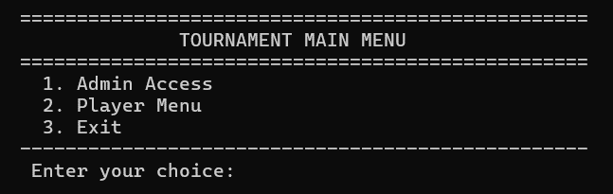
Figure 11.1 (Admin Menu)
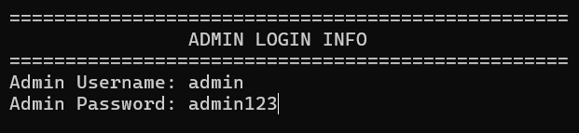
Figure 11.2 (Admin Login through Credentials)
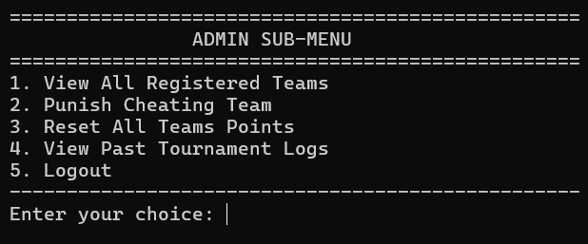
Figure 11.3 (Admin Feature)
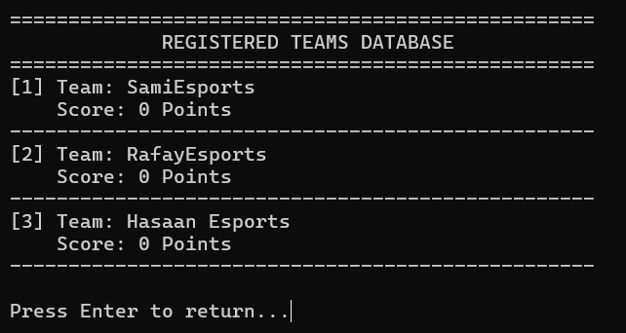
Figure 11.4 (1st Feature)
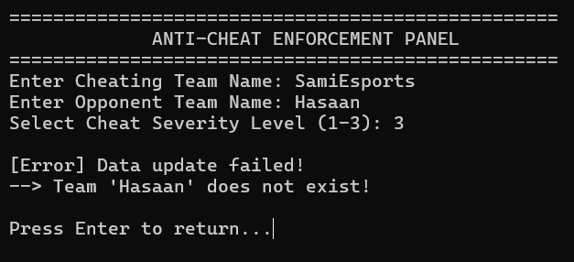
Figure 11.5 (2nd Feature)
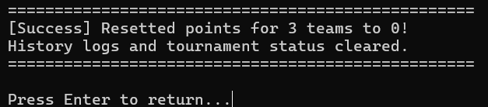
Figure 11.6(3rd Feature)
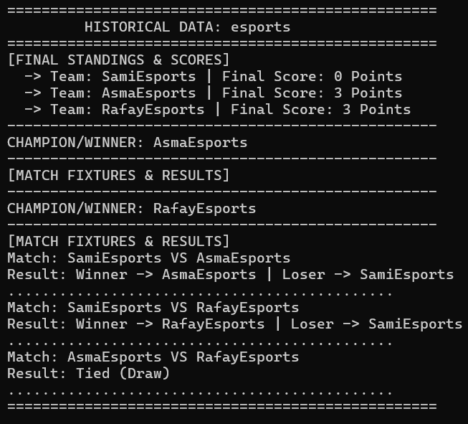
Figure 11.7(4th Feature)
Figure Player:
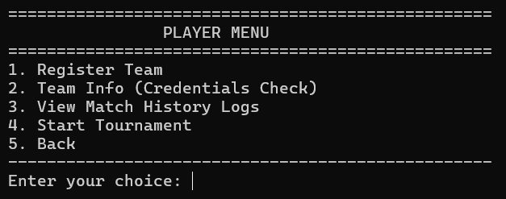
Figure 11.8 (Player menu)

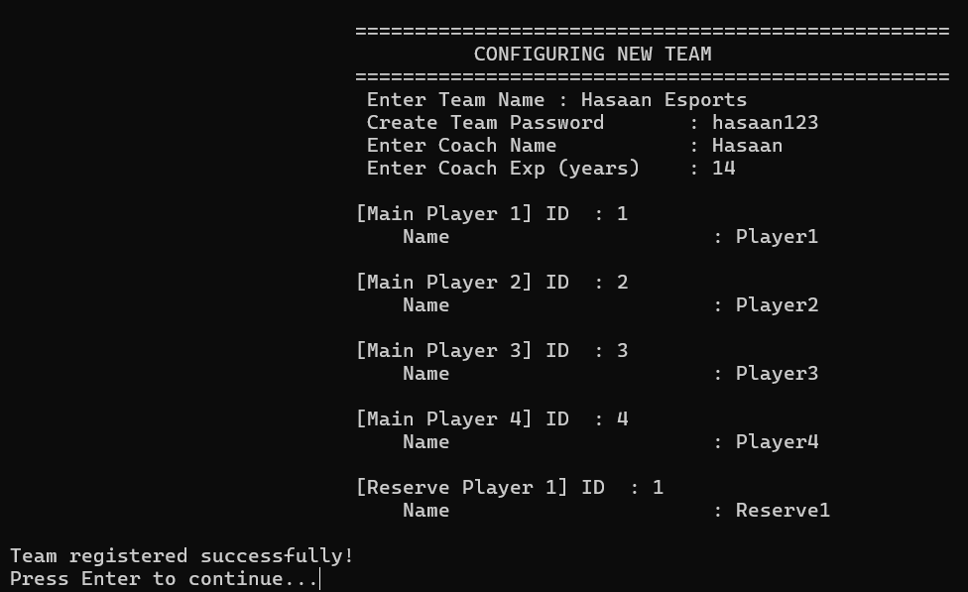

Figure 11.9(Register Team)

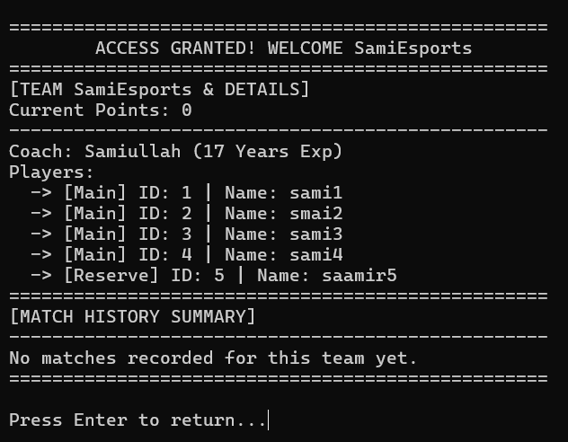

Figure 11.8(Team Information)

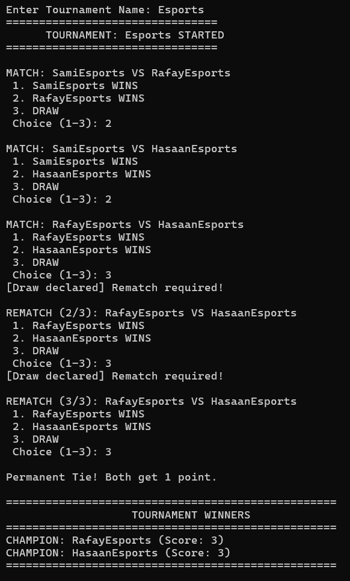

Figure 11.9(Start Tournament)

12. Conclusion
The E-Sports Tournament Management System highlights how Object-Oriented Design principles successfully solve real-world tournament operational issues. Leveraging inheritance models eliminates redundancy, while encapsulation and abstraction ensure highly maintainable data paths. Integrating structured file streams with explicit pointer destructors results in a highly dependable software layout capable of scale, security, and consistent execution.

